Contact:  Andreas Reich  Hilma-Roemheld GmbH  Head of Quick Die Clamping Systems  Tel.: +49 2739 4037 162  Email: a.reich@hilma.de  F. Stephan Auch  auchkomm Unternehmenskommunikation  Tel.: +49 911 27 47 100  Email: fsa@auchkomm.de | Römheld GmbH  Friedrichshütte  Römheldstraße 1-5  35321 Laubach  Germany  Tel.: +49 (0) 6405 / 89-0  Fax: +49 (0) 6405 / 89-211  E-mail: info@roemheld.de  www.roemheld.com

Press Release 2/2024

- ROEMHELD: New Rail-Guided Die Changing Table for Simple, Safe, and Fast Transport of Loads Up to 40 Tonnes
- Innovative solution reduces set-up times needed for die change
Laubach, April 16, 2024 — ROEMHELD announces the new, rail-guided RWS die changing table for transporting heavy dies and moulds. The innovative solution is available in three versions for loads of up to 15 tonnes, 25 tonnes, or 40 tonnes per die. Electrically driven, the system is equipped with two different pull-push systems for the safe and automatic transport of dies to set up presses. It can be used to change dies and moulds on all types of machines, including vertical forming and injection moulding machines.
RWS is ROEMHELD’s answer to today's trend where loads in die and mould making are ever increasing. This solution helps car manufacturers integrate numerous individual parts into increasingly large castings, for example in megacasting for frame or body manufacturing. They are processed with heavier dies in larger presses and punches. ROEMHELD understands these new requirements and is expanding their range of die weights to accommodate heavier loads.
RWS is an innovative solution that ROEMHELD has now launched together with a transport and handling company from the German region of East Westphalia.
Safe transport system with minimal rolling resistance
The die changing table is guided on floor-level round rails. These rails have a rolling resistance so low that loads of up to 5 tonnes can easily be moved manually by just one person. In addition, the rails are designed to facilitate precise carriage guidance and to prevent dirt deposits and tripping hazards in the floor.
Consoles that bridge the distance between the press bed and the die changing cart make transport effortless. RWS has an integrated pull-push system that then moves the dies onto and off the press bed via roller rails. A safety mechanism ensures that the loads can only be moved when the RWS die changing table is firmly attached to the press or the storage space.
Suitable for various presses
RWS is available as a single or tandem cart and can be used flexibly in a wide range of production scenarios. For example, it can travel between a storage space, a set-up station, and a single press. It can also shuttle between several bearing locations, set-up stations, and presses. Alternatively, it also enables several presses to be connected to just one changing table. This means that the presses are free during preparation and can produce right up to die change.
With this solution, ROEMHELD is able to meet the growing requirements of customers resulting from today’s trend of employing connected presses and complete solutions. Dies of different sizes can be easily changed with one system because a standardized base plate is used. Semi-automatic and fully automatic die changes are possible thanks to the control system that is integrated in the cart and precise positioning. Other available features include integration with the press control and the ability to combine with rapid-clamping system for dies.
Change tonne-heavy dies safely and efficiently
The amount of time needed for actual changeover is also minimized because the die changing table is equipped with integrated lifting bars and a pull-push system. Also important for operators: in the semi-automatic system version, the cabled remote control (wireless also available) enables simple, safe, and centralized control of the cart.
Compared to free-moving transport systems, the rail-guided die changing table receives high marks with numerous advantages: maximum repeatability and precision of up to ±0.3 mm, lower energy consumption and space requirements, and greater availability. In addition, installation of floor-level round rails generally places fewer demands on the factory floor.
Comprehensive, integrated portfolio of solutions for dies
RWS rounds out ROEMHELD’s comprehensive, integrated portfolio of solutions for transporting and changing dies and moulds from the rack system to the press bed. This set-up time optimising solution thus meets customer requirements for complete systems that store, transport, change, and clamp forming dies.

About the ROEMHELD Group
From medical engineering and mechanical engineering to the automotive, aerospace and agricultural industries or the production of smartphone cases: technologies and products of the companies in the ROEMHELD Group have been used to manufacture numerous industrial commodities and goods for end users for more than 80 years.
The ever-growing range of more than 25,000 catalogue items includes innovative and intelligent solutions for manual and automated clamping and set-up of dies, workpieces, fixtures and pallets as well as for handling and assembly. They are used by numerous industrial companies worldwide, especially in machining, forming technology, plastics processing and 3D printing.
The focus is always on efficiency and productivity — through minimum set-up times, fast manufacturing and high flexibility.
Innovation through tradition: ROEMHELD was established in 1707 with a foundry in Friedrichshütte, which still belongs to the ROEMHELD Group today and counts as one of Germany’s oldest active industrial businesses.
Three members belong to the owner-managed group of companies. Römheld GmbH Friedrichshütte, Laubach, Germany, is responsible for workholding elements, assembly and handling technology as well as die clamping and change technology. Zero point clamping systems, machine vices and tower workholding systems are produced by STARK Spannsysteme GmbH, Rankweil, Austria. Technical consulting and development of machine vices, tower workholding systems as well as die clamping and changing technology takes place at Hilma-Römheld GmbH in Wilnsdorf, Germany.
The Group employs around 530 people and is represented by service and sales companies in over 50 countries. It achieves an annual turnover of more than 90 million euros.

Photos:
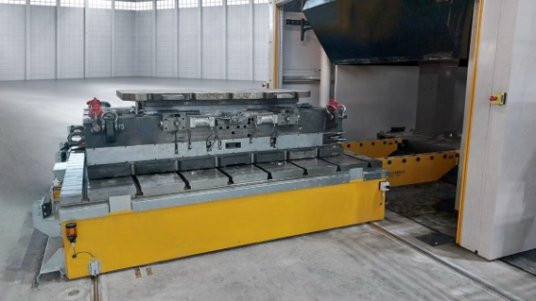
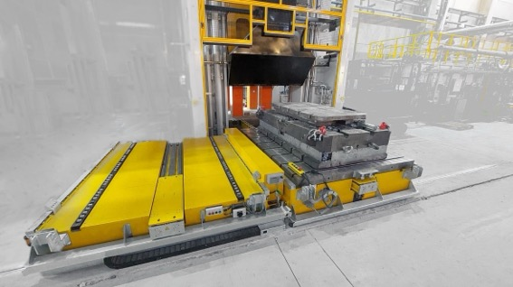
Photos 1 (above) and 2 (below):
ROEMHELD announces a new, rail-guided shuttle table for transporting heavy tools and moulds weighing up to 40 tonnes (photo: ROEMHELD).

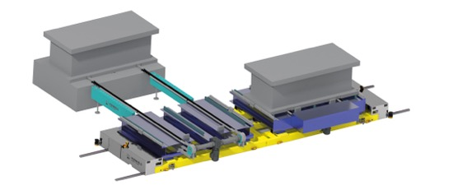
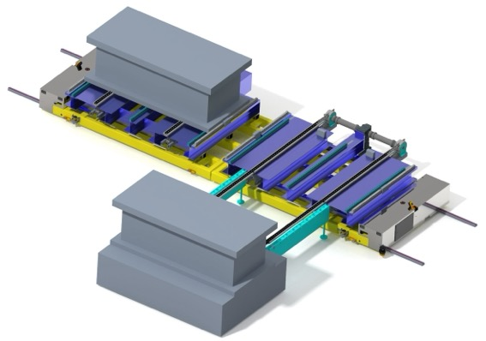
Photos 3 (above) and 4 (below):
RWS is available as a single or tandem cart and can be used flexibly in a wide range of production scenarios (photo: ROEMHELD).
Download the press release as a Word document and the images in print quality here:
https://www.auchkomm.com/aktuellepressetexte#PI_560

Author's copy requested:
auchkomm Unternehmenskommunikation, F. Stephan Auch, Hochstraße 11, D-90429 Nuremberg, fsa@auchkomm.de, www.auchkomm.de

